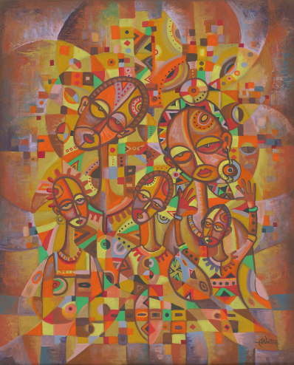

USPG Conference
Evening Prayer
July 26, 2022
PRELUDE:

Call to Worship:
L: The work of God surrounds us:
C: We respond with praise
L: The love of God is visible: C: We respond in faith
L: The word of God is calling:
C: We respond in hope
L: The wind of the Spirit is blowing: C: We respond with joy.

TAIZE CHANT: (as people sing the song they will meditate on a painting on the screen)

Confitemini Domino,Quoniam Bonus!
Confitemini Domino,Alleluia!

Give thanks to the Lord, For he is good!
Give thanks to the Lord, Alleluia!

CONFESSION:
L: L: Triune God, the source and the ground of our being we confess that we have distanced ourselves from you, our neighbours and your creation:

All: By our self-centredness - when inspite of recognising deep needs, we have been too selfish to put ourselves at risk or cost that these may be met

By cowardice - when inspite of having visions of good, we have been slow to be faithful in a daring and adventurous way
By haste - when we acted too quickly, and thought too late

By irresponsibility - when we opted for silence, when we should have communicated compassion

Have mercy upon us. Come to us in love, that we may not flinch from your love’s embrace, nor decline your forgiveness, nor be closed to your calling of us once again. Amen.

ASSURANCE:

L : Listen, for God speaks in Christ Jesus saying
‘Your sins are forgiven. You are set free.
Go in peace, come and follow me’.

All: Amen. Thanks be to you O Christ.

SILENT MEDITATION ON A WORK OF ART: A piece from Stations of the Cross by the Argentinian Nobel Laurete Adolfo Esquivel. Accompanying commentary by Alastair McIntosh of Scotland.

PRAYER: As we remember all those struggling for environmental justice we remember USPG’s own partners. A time of open prayer (spoken and silent) remembering people and places close to our hearts. Followed by the Lord’s Prayer in a language of our choice.

PRAYER BASED ON THE LORD’S PRAYER: A New Zealand Prayer Book:
He Karakia Mihinare O Aotearoa (1995)

All: Eternal Spirit, Life-Giver, Pain-Bearer,
Source of all that is and that shall be,
Father and Mother of us all,
Loving God, in whom is heaven:
The hallowing of your name echo through the universe!
The way of your justice be followed
by the peoples of the world!
Your heavenly will be done by all created beings!
Your commonwealth of peace and freedom
sustain our hope and come on earth!
With the bread we need for today feed us.
In the hurts we absorb from one another, forgive us.
In times of temptation and test, strengthen us.
From trials too great to endure, spare us.
From the grip of all that is evil, free us.
For you reign in the glory of the power that is love, now and
forever. Amen.

SONG: YARABBA SSALAMI (Palestine)

Ya – ra- bba ssa-la-mi,
am-ter a-lay-na ssalam
Ya –ra-bba ssa-la-mi
Im la’ qu-lu-ba-na sa-lam

God of peace, in your wisdom,
Give us the will to seek peace.
God of peace and of healing,
Fill with your peace every heart!
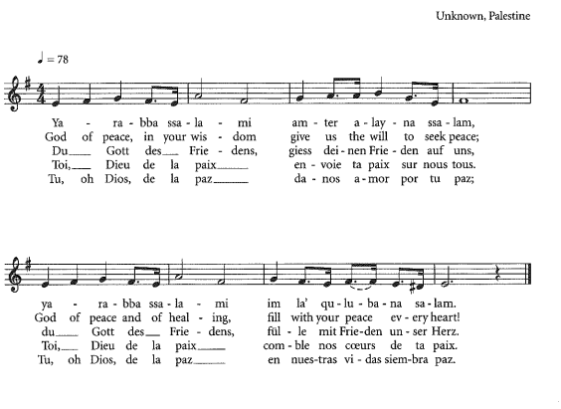

BLESSING:
May God grant us a vision of a community as God’s love would make it: a household where peace is built with justice and justice is guided by love.
May the Triune God give us the inspiration and courage to build such a community, and
May the grace of our Lord Jesus Christ, the love of God and the enabling accompaniment of the Hoy Spirit be with us all now and for ever more. Amen.

