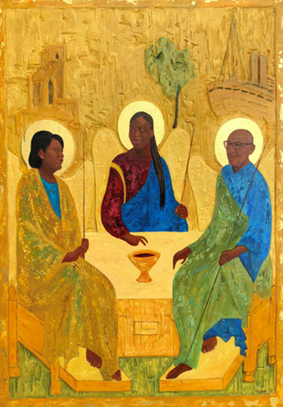

USPG Conference
Evening Prayer
July 25, 2022
PRELUDE:
OPENING LINES:
L: I will light a light in the name of the Maker who lit the world and breathed the breath of life for me. (a lamp or candle is lit)
L: I will light a light in the name of the Son who saved the world and stretched out his hand to me. (a lamp or candle is lit)
L: I will light a light in the name of the Spirit who encompasses the world and blesses my soul with yearning. (a lamp or candle is lit)
All: We have three lights for the Trinity of love:
God above us
God beside us
God beneath us:
the beginning, the end, the everlasting one. Amen

TAIZE CHANT:
Stay with us O Lord Jesus Christ. Night will soon fall.
Then stay with us O Lord Jesus Christ. Light in our darkness

CONFESSION:
L: Living God, if we have lost the wonder of life in your Spirit and cannot remember its passion and promise:
C: forgive us, O God. Stand before us in light and fire to warm our lives.
L: If we dare to believe that the Spirit speaks in only one language, which is ours, and we no longer expect to find you in unexpected people and places:
C: Hold our minds open to look at them with wisdom in case they are the bearers of your word.
L: If we refuse to engage with the stirring of uneasiness, the challenge to what we know, when we become preoccupied with things that are insignificant, losing your perspective in our feverish little causes:
C: Confront us with the truth through your Holy Spirit. Amen.
(modified from a prayer by Dorothy McRae-McMahon)

ASSURANCE:
L : May the flame of God’s loving presence spring up in our hearts and transform us by the knowledge of God’s glory.
All: Your Word is a lamp to guide us and a light for our path. Guide us, O God, by your Word Spirit, that in your light we may see light, in your truth find freedom, and in your will discover your peace; through Jesus Christ our Lord. Amen.
(Church of South India, Alternative Liturgy)

SILENT MEDITATION ON A WORK OF ART: Jyothi Sahi (India) – Jesus with People (based on Luke 4)

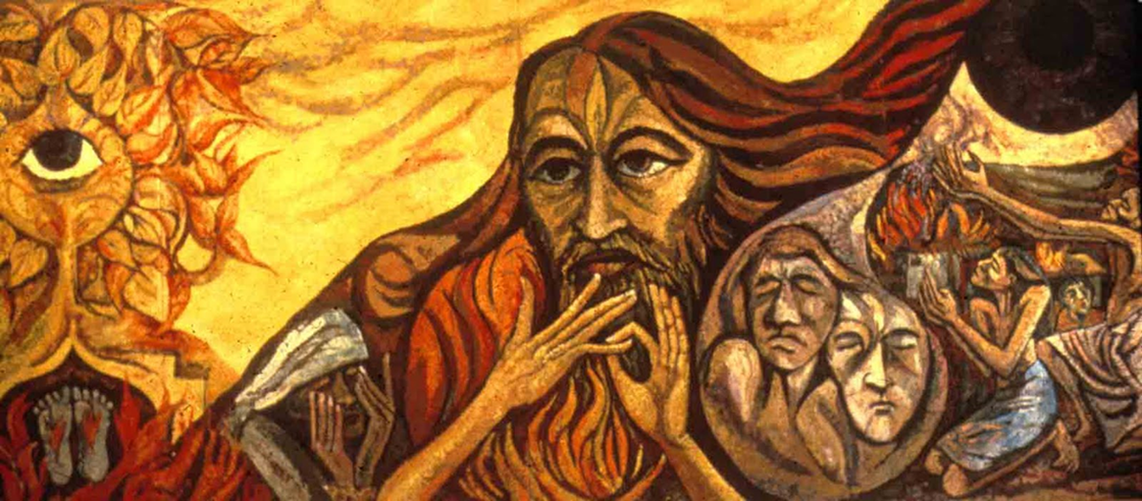

PRAYER: A time of prayer (spoken and silent) remembering people and places close to our hearts.

Followed by the Lord’s Prayer in a language of our choice.

SONG:
Thuma mina, Thuma mina, Thuma mina, Somandla (3x)

Send me Jesus, send me Jesus, send me Jesus, Send me, Lord (3x)
Lead me Jesus, lead me Jesus, lead me Jesus, Lead me, Lord (3x)
Fill me Jesus, fill me Jesus, fill me Jesus, fill me, Lord (3x)
Use me Jesus, use me Jesus, use me Jesus Use me, Lord (3x)

LITANY FOR THE NIGHT:
L: The night is the cover of your peace, O God,
All: the rhythm of your rest for all your people.
L: The darkness is the cloak of your gentleness, O God,
All: the warmth of your hand around the earth.
L: In its blackness is the sign of your eternity,
All: the never-ending living of your love.
L: In faith we go to sleep and leave our life to you.
All: in child-like trust we end our efforts of this day,
L: In our sleeping be our company,
All: in our waking be the gift of our new day.

L: Go in peace, and may God go with you. Christ Jesus take you by the hand and the Spirit be a cloud of grace around you. Amen

